Community Food and Nutrition Skills Course
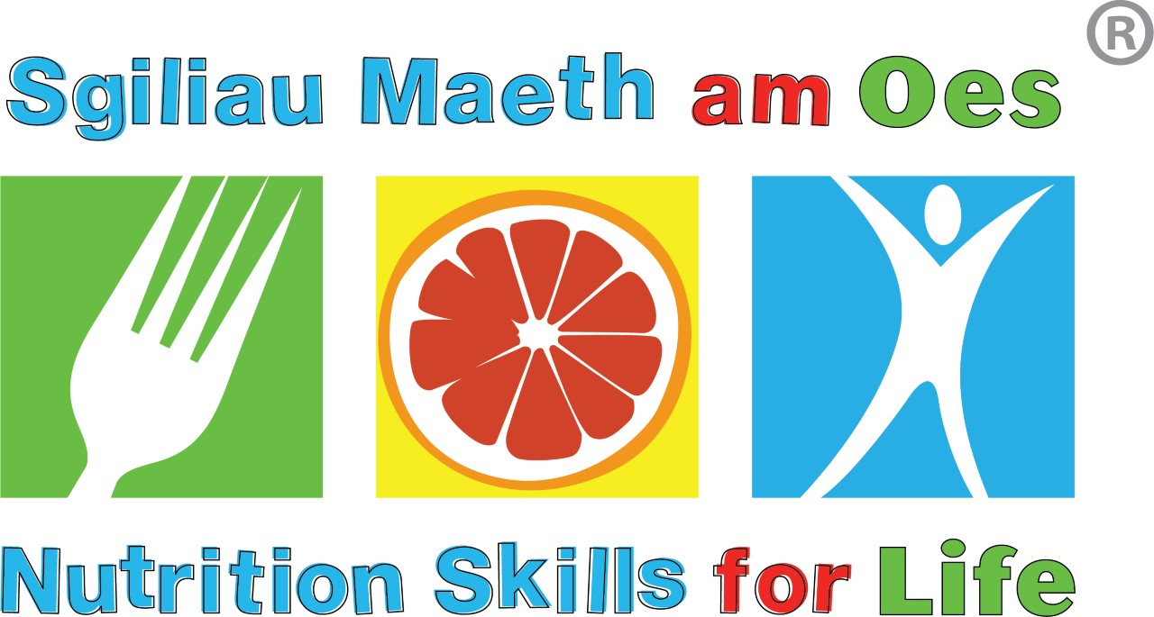

Agored Cymru accredited (Level 2, 3 credits)

Want to know more about food and nutrition?

What is the course about?
The course aims to increase knowledge and skills in food and nutrition. Following the course, participants will be able to pass on basic, up-to-date information to those they work with and support them to eat well. The course will provide ideas and resources to use with client groups.
There will be support available after the course for those who want to put their learning into practice and deliver healthy eating messages to their groups.

Course content:
Module 1 | Healthy eating guidelines and the Eatwell guide
Module 2 | Nutrition and health
Module 3 | Healthy weight management
Module 4 | Factors affecting food choice and eating well on a limited budget
Module 5 | Barriers to a healthy diet and helping people change their eating behaviours
Module 6 | Food labelling
Module 7 | Nutrition for specific client groups
Module 8 | Menu planning and adapting recipes
Module 9 | Food facts and myths & useful food and nutrition resources

Who is the course for?
Anyone working with families, groups and individuals in the community where healthy eating messages can be encouraged for example, teachers, teaching assistants, housing association staff, youth workers, support workers, leisure centre staff, and those providing childcare.

What time commitment is involved?
The course involves 30 hours of learning and upon completion is an accreditation of three credits. Delivery is typically classroom based however due to current government restrictions it has been developed and is now also delivered virtually.

Face to Face 20hours in the classroom and 10hours at home

When will it start and where?
8th July – 9th September

For more information or to book a place, contact Public Health Dietitian on 029 20907699.

